Internet Course outline
- Internet History
- Search Engines
  - Google, Being, yahoo
- Internet Browsers
  - Google Chrome, Firefox, Opera , Internet explorer, Microsoft Edge, Brave, Saffari
- Domain Register and web Hosting Providers
- ChatGPT
- Social Media
YouTube , WhatsApp , WhatsApp web, Facebook
- Email Address
  - Google Mail, Microsoft outlook, Apple iCloud
- Desktop Sharing and Remote Control
  - Team Viewer, Any Disk, Zoom
- Torrent
  - Torrent Clients and sites, downloading pirated apps
- Downloading and Uploading Media
- Download Devices Drivers
- Download System Softwares
- File Hosting Services and synchronization
  - Google Drive, Microsoft OneDrive
- Online Newspaper, TV Channels
Internet Modum
Cat 6 cable
Wire combination
RJ45 connector
Crimping tool
Ethernet Communication Port
Ethernet Port Driver
Wireless Catcher
Internal (PCI Slot) and External (USB Port) Catcher

TCP/IP
World Wide Web
FTP
File Transfer protocol
7 layers
URL
Uniform resource locatord

https://www.google.com/
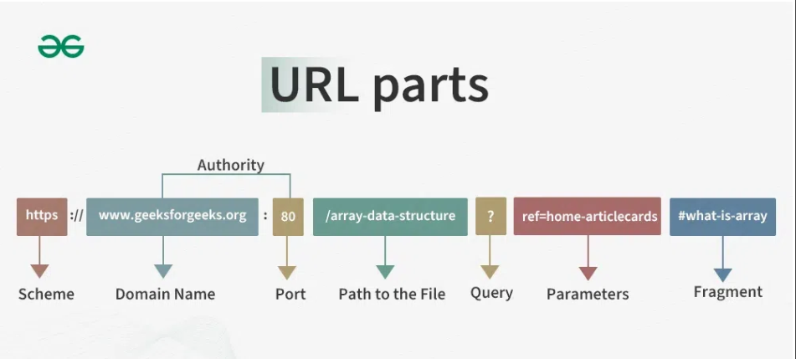
Hypertext Transfer Protocol Secure

World wide web

.net
.pk
.com
.gov.pk

Bowsers
- Internet explorer
- Google chrome
- Firefox
- Opera
- Sufari
Search Engine
Ctrl+T new Tab
www.google.com
Searching
Browsing
Downloading

.docx
.xlsx
.pptx
.pdf

www.hotmail.com
www.gmial.com
www.facebook.com
www.dropbox.com

https://temp-mail.org/en/

TCP/IP
Transmission Control Protocol

alinasar@gmail.com

www.gmail.com

cat 6 cable
RJ 45
rj45 crimping tool
rj45 colour code cat 6

wireless catcher
poe switch
wireless router
Dropbox
Google drive

How to download and Install Chrome from google
How to signing in to chrome
Bookmarks and how to enable bookmarks bar in chrome
Web store (Extension)
Chrome shortcut keys
Tabs Ctrl+T
Address bar Ctrl+L
Download History Ctrl+J
How to clear all time history in google chrome
Clear History Ctrl+H
Bookmark Ctrl+D

How to create gmail id

